Saturday, April 18, 2015

If you have any questions about Sponsorship

Please contact

Jennifer LaMar,

Art teacher and

Art Club co-advisor at Warren High School:

jlamar@dusd.net

**Form Needed back

by April 15

WE NEED SPONSORS!!!!

All donations are tax deductible.

Tax ID # 95-6006586

If you know someone participating and would like to sponsor them specifically, please indicate that below, writing their full name.

**This event is for ALL AGES**

Chalk Art will be judged for the following categories:   
  
Best Rendition of a Masterpiece  
Best Use of Color  
Best Humor  
Most Original  
Best Team artwork  
Best Youth (children 12 and under)

Contest Begins at 9:00am

Judging begins at 3:00pm

If you are interested in entering or know someone who is, please visit our website: <http://warrenartclub.weebly.com/> or send an email to jlamar@dusd.net

*Cash or Check accepted*

*Please write checks to “Warren High School”, and write “Art Club” on the memo line.*

C:\Users\jlamar\AppData\Local\Microsoft\Windows\Temporary Internet Files\Content.IE5\AYPTRQ5T\MC900434663[1].wmf**Event Sponsorship Levels:**

*Donations in kind will be recognized as sponsors according to value of donation.

|  |  |
| --- | --- |
| $25  $50  $100  $500+ | Chalk Artist Sponsorship  Da Vinci Sponsorship  Picasso Sponsorship  Van Gogh Sponsorship |

**Benefits of being a sponsor:** All sponsors will be recognized on our website on the sponsor’s page with link to their webpage (if desired and applicable) and will receive sign recognition at the event. Each sponsor can choose sponsor a specific artists’ square if they know someone participating.

All money raised at this event goes towards our Art Club Scholarships for Warren High School Seniors, who have dedicated many service hours to Art Club and the Arts. Without your support this would not happen. Support our community’s budding artists; give them an opportunity to shine, and a chance at advancement.

-----------------------------------------Detach here (Sponsor keeps top portion, Art Club Member keeps lower portion) -----------------------------------------

Please check level of sponsorship:

**Sponsor Name: ____________________________________________**

**Company Name (if applicable):__________________________________**

**Address:__________________________________________________**

**__________________________________________________________**

**Email:_____________________________________________________**

**Phone #: ________________________**

**Website (to link from our webpage if applicable):**

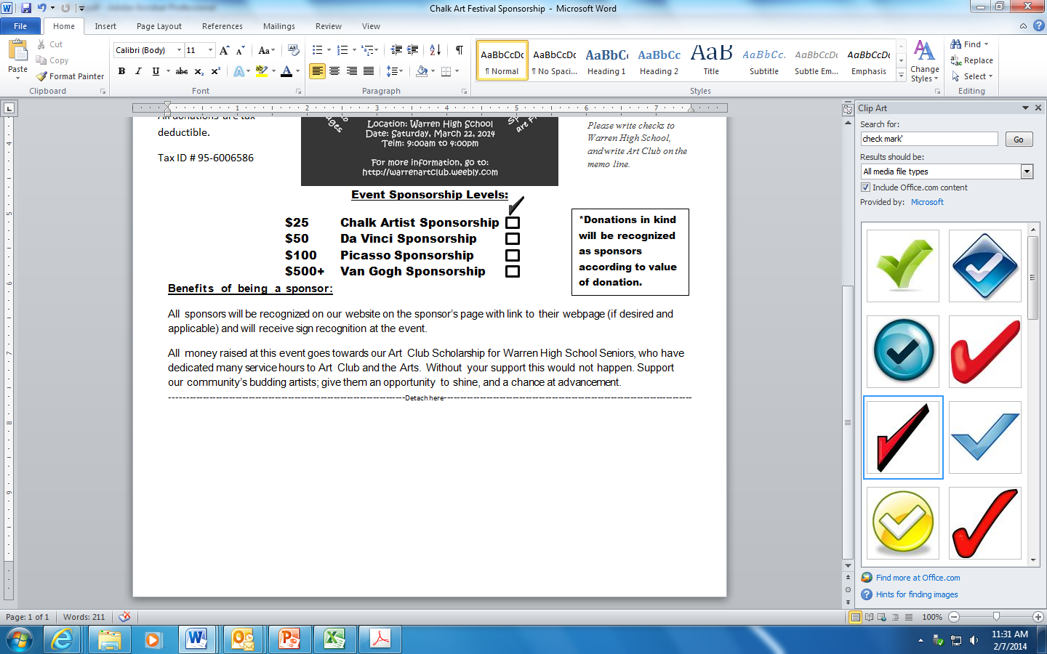

(If applicable) Name of person being sponsored:

Amount paid $____________

Cash

Check

(For art club uses only) Name & Phone # of Art club member: